Danielson Framework Summative Evaluation Rubric

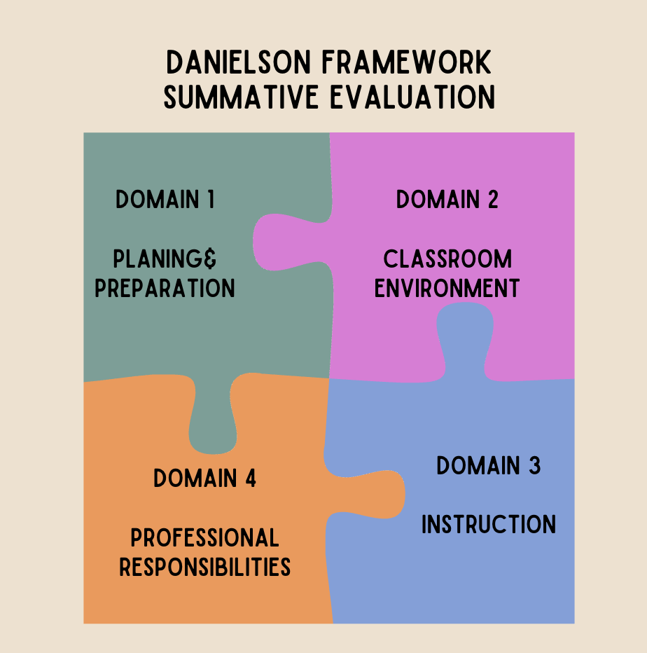

Domain 1: Planning and Preparation

Component | Unsatisfactory:  Unacceptable  1 | Basic: Novice Student Teacher  2 | Proficient:  Effective Student  Teacher  3 | Distinguished:  Advanced Student  Teacher  4
1a
1b
1c
1d
1e
1f
1g

Domain 2: Classroom Environment

Component | Unsatisfactory:  Unacceptable  1 | Basic: Novice Student Teacher  2 | Proficient:  Effective Student  Teacher  3 | Distinguished:  Advanced Student  Teacher  4
2a
2b
2c
2d
2e

Domain 3: Instruction

Component | Unsatisfactory:  Unacceptable  1 | Basic: Novice Student Teacher  2 | Proficient:  Effective Student  Teacher  3 | Distinguished:  Advanced Student  Teacher  4
3a
3b
3c
3d
3e
3f

Domain 4: Professional Responsibility

Component | Unsatisfactory:  Unacceptable  1 | Basic: Novice Student Teacher  2 | Proficient:  Effective Student  Teacher  3 | Distinguished:  Advanced Student  Teacher  4
4a
4b
4c
4d
4e
4f
4g

